

Add cover Add comment

**Liquidity Voids**

Liquidity void is where there was absolutely no trading taking place at all, this is a liquidity void. On CPI or another big news event, neither buyside or sellside was offered. Just a big candle where no one could buy or sell. Take the 10-11-2022 CPI candle as example, thats a liquidity void

Liquidity voids where there was no trading at all, those are the best for a draw on liquidity

When price is in a small trading range or consolidation we call it price in balance or at equilibrium At some point price will move away, this causes a price imbalance and we call it displacement

The price imbalance can stay open for a while, theres no specific time to fill a liquidity void. Its going to be relative to what youre seeing in price action around the void.

A liquidity void is big candles delivered to 1 side, with occasionaly a small gap between the big candles

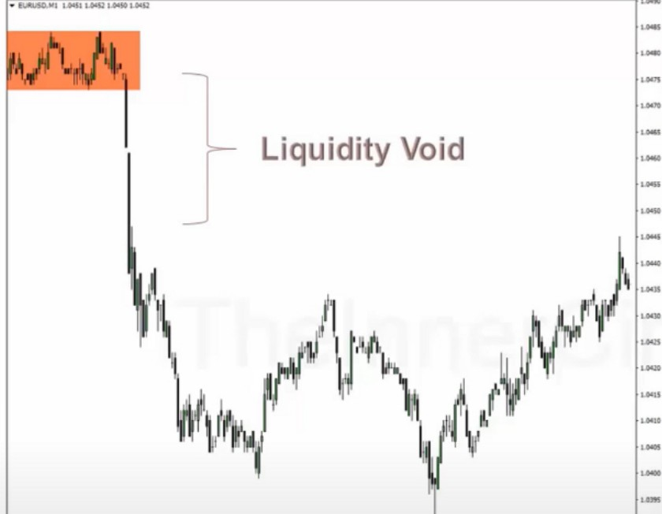

**Reinforcing Liquidity Voids**

[Wre11 To Anticipate Ranges To fill In)

**Liquidity Void** is a range in Price Delivery where one side of the Market Liquidity is shown in long one sided ranges or candles. Price typically will want to revisit this "range" or void of contrarian liquidity.

Sometimes they run the consolidation and they the buy stops and then drop, but thats not the point of this video

The liquidity void will be covered back over in some future time with bullish price action that will cover the entire range, and when it does that price has been balanced out, price has been offered on the sellside and on the buyside

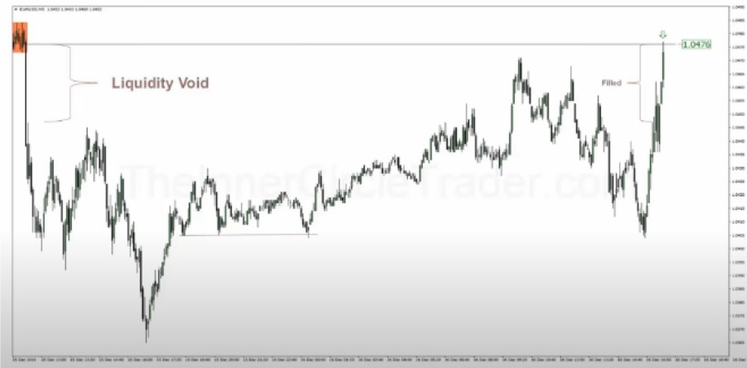Now you would expect price to completely fill the void, sometimes it does happen instantly but sometimes it first drops lower faking people out and then fill it completely like on the right example

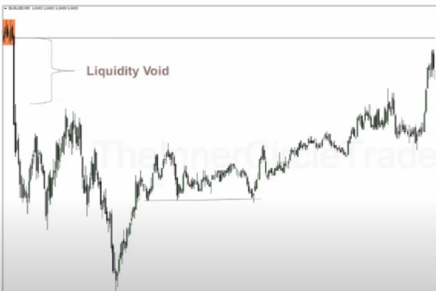

· ·

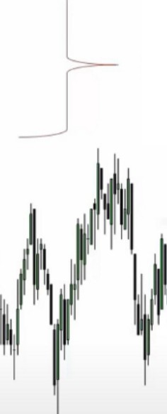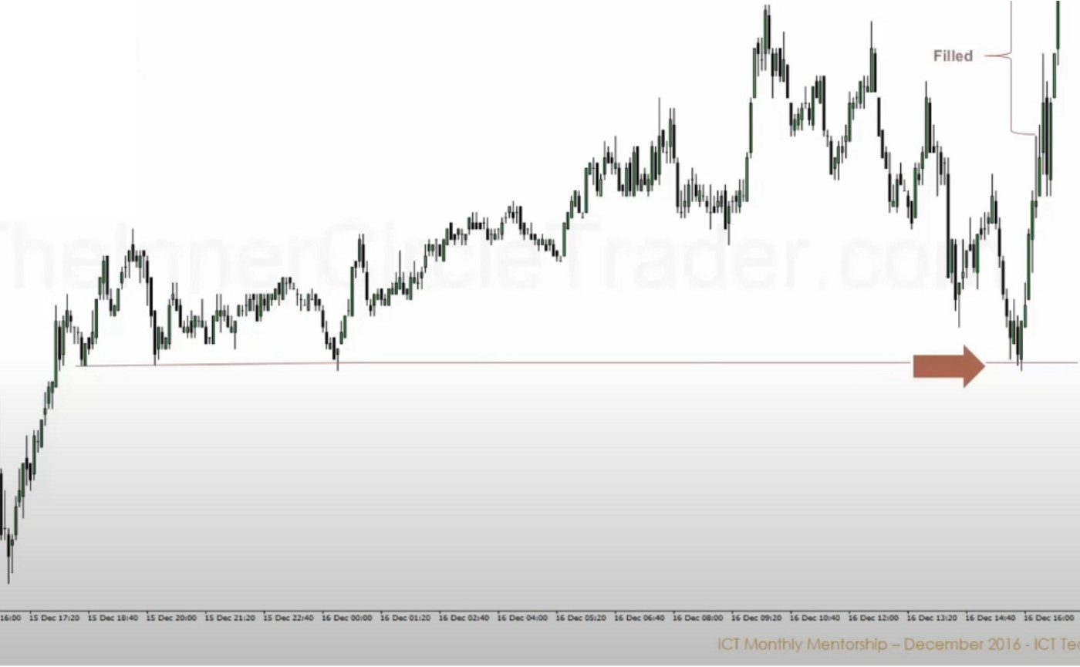

.I).

.,._- -------------------- -----i---!1.0'!761

**Liquidity Void**

Buying opportunity

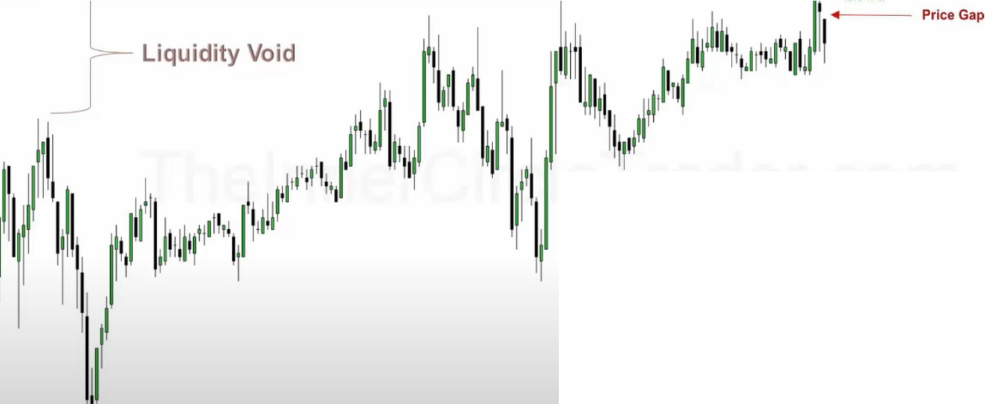

0

l♦li- ==-...------------., ------h-- 1.0476

When price moves away aggresive like this with a gap, we know its high probability that it will go lower. And its tried a couple times to get up there,

And remember pricing in on an institutional level, has to happen in graduated terms, in other words

it cant be done on the first pass. It runs away from a level and then gradually runs back up to the level once and sells off and then comes back one more time, theyre stacking orders to go lower

Liquidity void is a gap during price trading, when price trades from 1 candle to the other so 1 bearish closes then the next 1 opens lower thats a gap. What can we do with the gap? We know price likely will go lower, so we can sell in that gap

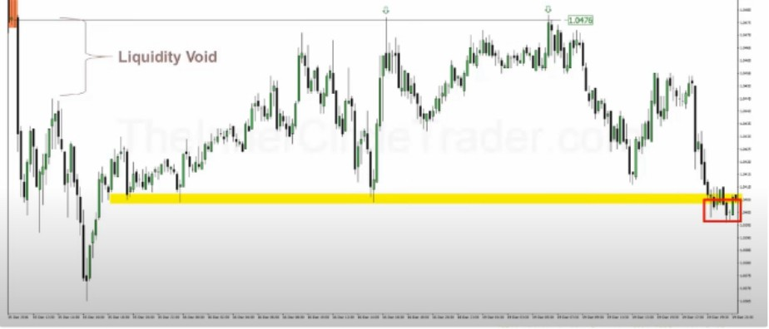

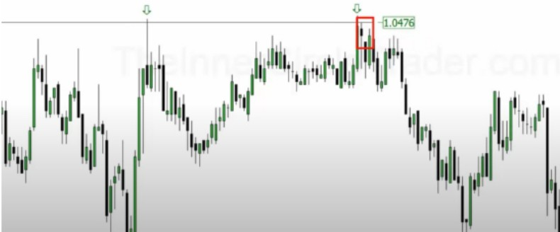

Look at how the body closes it in

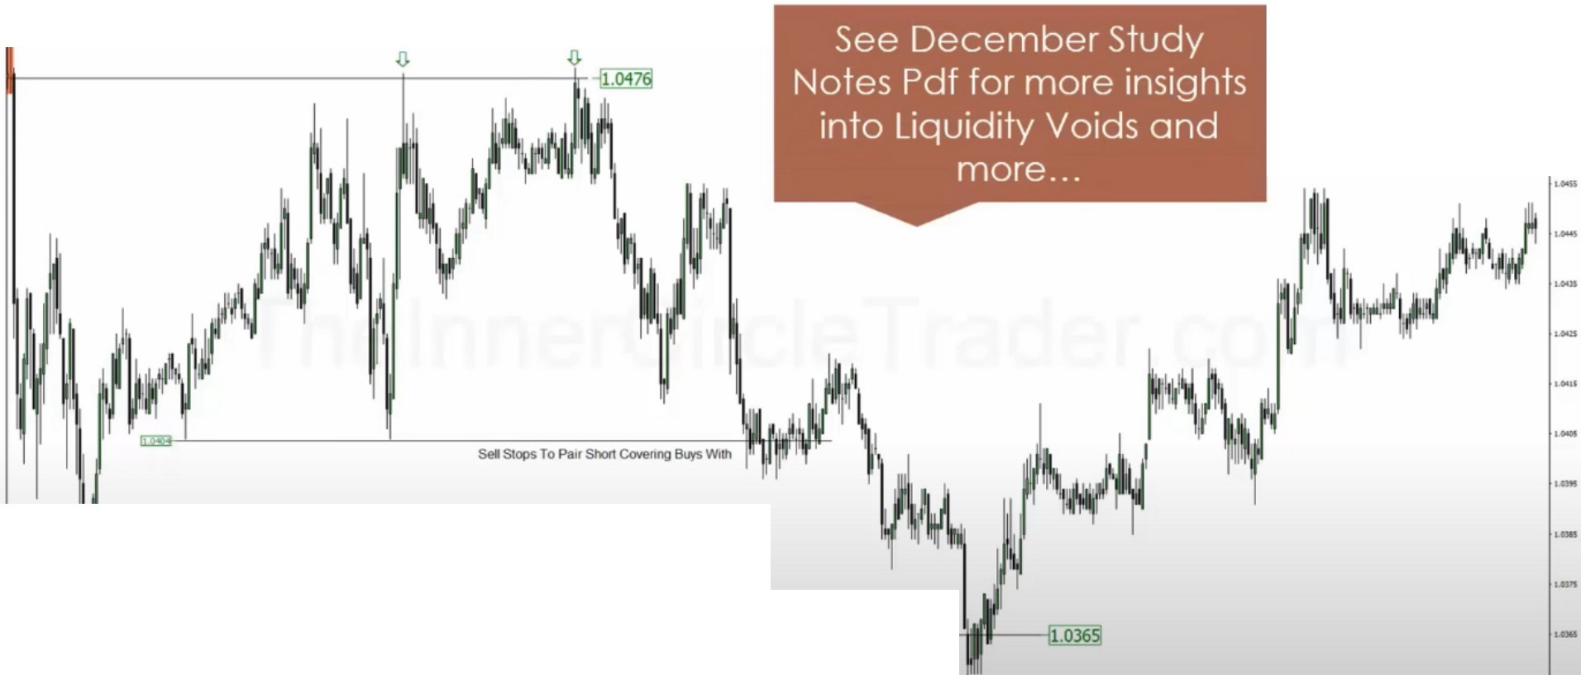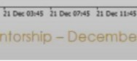

**Se1S!opsTo Paw Shon CoYeflng &,,/5 With**

Arjo I Twitter, lnstagram I Linktree

Linktree. Make your link do more.

I https://t.co/HhmmTN1fUI

JavaScript is not available.

***"'!I*** https://twitter.com/arjoio